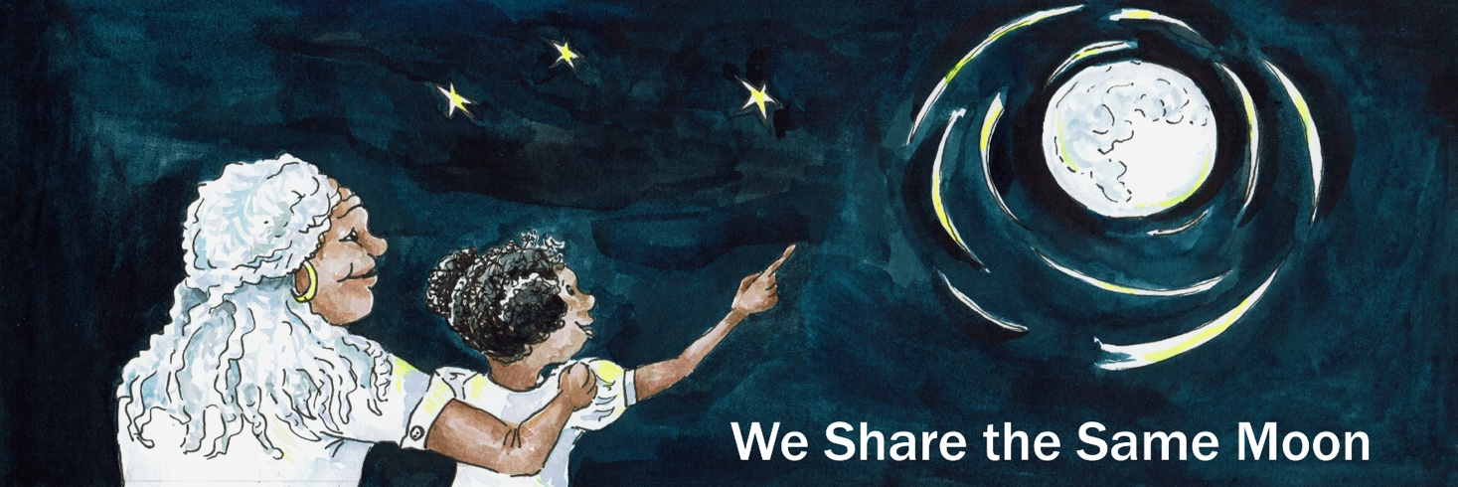

Suggested Age Range: 3 - 4 years: 4 - 5 years
Suggested UK Year Group: EYFS Nursery: EYFS Reception
UK Curriculum: EYFS
UK EYFS Curriculum Link : Understanding the World
Science Subject: Surface of the Moon
Science Question: What can you see on the Moon?
Suggested Science Activity: Cosmic Craters; Moon Globes; Moon Hats; Solar System Touch Boxes
Children with SEND: Use with children with speech and language disabilities
EAL children: Beginners level
Country of Origin: Peru
Source: Moon Rope by Lois Ehlert

Long ago in Peru. Peru was a land filled with grass, a very special grass, called Pampas grass, that stretched as far as the eye could see.

And, in the middle of this land of grass, there was a tiny hole, that led to a big tunnel, that went down and down and down into the Earth. And living in this tunnel was a Mole.
Mole sleeps all day, but when the Moon rises in the Sky, whoosh.
He wakes up. Yawns. And thinks “Hmmmm, I’m hungry!”
Now, Mole cannot see very well, but, he can smell really, really, really well!
So he sniffs, and sniffs, and sniffs.
And then he digs and digs and digs, until he finds …
“Ahah! A nice big fat juicy worm!” And then, he eats it!
Once Mole has finished eating, he climbs out of his tunnel and he sits with his friends. They chit and chat and chit and chat and chit and chat by the light of the Moon.

But …
One night, Mole is all alone.
He looks up at the big round Moon in the Sky
And thinks ….. Hmmm.

“I wonder, are there more worms living on the Moon?
Than they are living down here on Earth?”
He thinks and thinks and thinks for a while …. Hmmmm.
But he doesn’t know the answer.
All of a sudden - he hears something!
Footsteps - running through the grass!

Gdum, gdum, gdum, gdum,gdum, gdum, gdum, gdum, gdum,

He sniffs and sniffs and sniffs. He smells his friend, Fox! “Hello Fox!” “Hello Mole!”
“Fox? asks Mole “Do you know - are there more worms living up on the Moon, than there are living down here on Earth?

Fox thinks for a while Hmmm!
“I don’t know” says Fox “Let’s go to the Moon and find out!"

“Go to the Moon!” says Mole ”But how?”
Fox thinks for a while. Hmmmm! He has an idea! Ting! \
“I know! We will climb to the Moon!”

"Climb to the moon? says Mole ”But how?”
Fox thinks for a while. Hmmmm! He has an idea! Ting! “I know! By rope!”

“By rope!” says Mole “But where will we find a rope?”
Fox thinks for a while. Hmmmm! Then, he has an idea! Ting! “I know! We will make one!"

"Make a rope!” says Mole “But how?”
Fox thinks for a while. Hmmmm! He has an idea! Ting!
“I know ! We will chop some grass and then we will tie it together to make a rope!”

So Fox and Mole:
They chop, chop, chop the grass. They chop, chop, chop the grass.
They chop, chop, chop the grass.

And then: They tie, tie, tie the grass. They tie, tie, tie, the grass. They tie, tie, tie the grass.
To make a very, very, very, long rope!
“But, what do we do next Fox?” asks Mole.

“Next” says Fox. “We make a great big circle of rope at one end and tie it with a knot. It’s called a lasso. Then we throw the lasso high in the air and over the Moon, to catch the Moon inside our circle of rope. Then we can climb up the rope to the Moon!”
So, they make a big circle of the rope.
They tie it at one end with a knot and throw it up into the air! 1,2, 3 throw!
But do they catch the Moon? No - it is too far away!
So they try again - a bigger throw! 1,2, 3 throw!
But do they catch the Moon! No - it is too far away!
So they try again - an even bigger throw! 1,2, 3 throw!
But do they catch the Moon? No - it is too far away!

But …
Mole sniffs and sniffs and sniffs and smells… Another friend! Flying high in the sky, is Owl!
“Owl - can you help us to catch the Moon?”
“Yes” says Owl “But how?”
“Take our special rope, it’s called a lasso, and then throw the circle of rope over the Moon”

Owl takes the rope in his beak and flies up and up and up into the air.
And then throws the lasso…… Wheeeeee!
And the great big circle of rope lands around the Moon!

“Yes! We did it! We caught the Moon” The animals shout with joy!
Fox starts to climb the rope:
Climb the Rope. Climb the Rope. Climb the Rope to the Moon!
Climb the Rope. Climb the Rope. Climb the Rope to the Moon!
Climb the Rope.Climb the Rope. Climb the Rope to the Moon!

Mole follows him up the rope:
Climb the Rope. Climb the Rope. Climb the Rope to the Moon!
Climb the Rope. Climb the Rope. Climb the Rope to the Moon!
Climb the Rope. Climb the Rope. Climb the Rope to the Moon!

But … Mole is smaller than Fox. He gets tired. He begins to slow down.
Climb the Rope. Climb the Rope. Climb the Rope to the Moon!
Climb the Rope. Climb the Rope. Climb the Rope to the …
He is very tired. He climbs slower and slower and slower ….
And then, his paws begin to slip ……
And then, he finds himself beginning to slide …. Down!
All the way back down to the ground! Bump!
Mole decides that he is NEVER EVER going to the Moon!
Even if there are more worms living on the Moon!
He will stay and eat the worms on Earth.
But what about Fox?
Well, they say in Peru - that if you look very carefully, you can see him up there on the Moon! Happily eating worms!
But …
Scientists say that there is no life on Moon, not even worms!
Because there is no air, no earth and no water on the Moon.
What do you think is true?
The End.

Retold by Cassandra Wye, copyright April 2019

